**30)**

**Aim:** To Draw a Deterministic Finite Automata for the language accepting strings ending with ’01’ over input alphabets ∑ = {0, 1}.

**Diagram:**

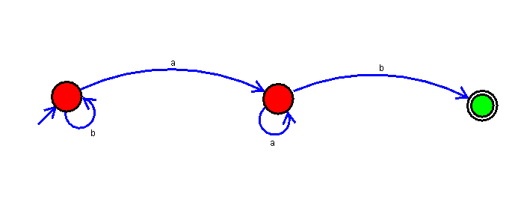

**Result:**

Thus, successfully executed Deterministic Finite Automata for the language accepting strings ending with ’01’ over input alphabets ∑ = {0, 1}.